Administrator Manual

I. Introduction
This Manual is only intended for administrators in your MedicEdge system in your organization. If you’re not an administrator, you can disregard this guide. But you can always read it if you want.
But I should point out that the administrator role in MedicEdge has the highest priveleges. And so, I will point out that with great power, comes great responsibility. With such authority comes the responsibility to ensure the security, integrity, and proper functioning of the system. Administrators must act with caution, follow best practices, and uphold ethical standards to prevent misuse, data breaches, or unauthorized access.

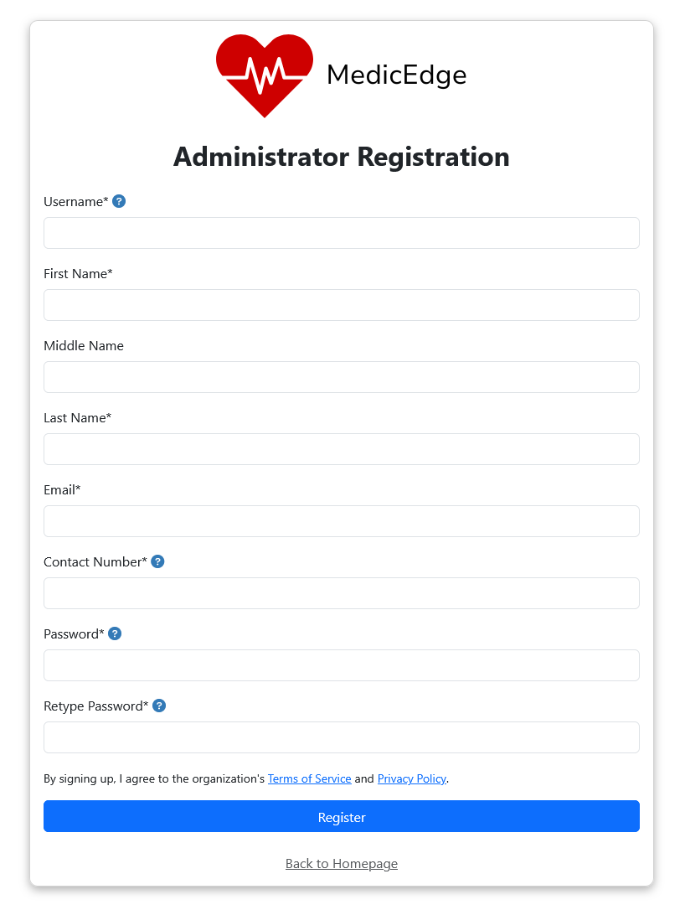
II. Adding a first Administrator
Signing up as an administrator in the system is easy. Just click the “Register as Admin” button in the homepage and fill out the forms. However, there’s a limit to that sign-up method. Once the system detected that there is already an administrator in the organization, you need to contact the admin(s) first so they can add you manually as an admin. This is done as a security measure, so as the administrator can manually audit those.

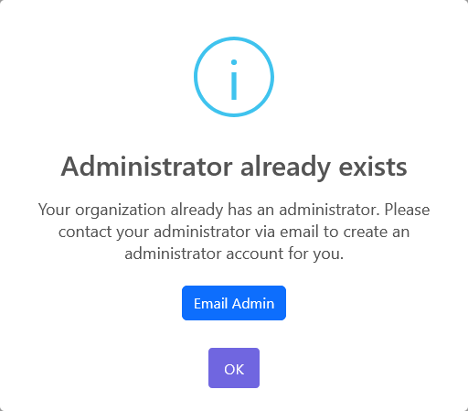

Pressing “Email Admin” button will open a link that will send a message to the current administrator of the organization (according to your default mail client of choice), with a pre-defined message to get you started. But you can edit it, of course.

